1. WRITE DIFFERNCES BETWEEN TRIGGERS AND HOW MANY TYPES OF TRIGGRS WE HAVE.

|  |  |  |
| --- | --- | --- |
| **Trigger Type** | **Description** | **Best Use Cases** |
| **Schedule Trigger** | Runs at a **specific time or interval** | Daily/weekly ETL jobs, scheduled data processing |
| **Storage Event Trigger** | Fires when a **file is created or deleted** in Azure Storage | Real-time ingestion, IoT data processing |
| **Tumbling Window Trigger** | Runs **at a fixed period**, ensuring **exactly-once processing** | Incremental loads, data partitioning |
| **Custom Event Trigger** | Uses **Event Grid events** to start a pipeline | Custom business events, advanced automation |

1. CREATE PIPLEINE AND EXPLORE VARIOUS TYPES OF TRIGGERS
2. Schedule trigger

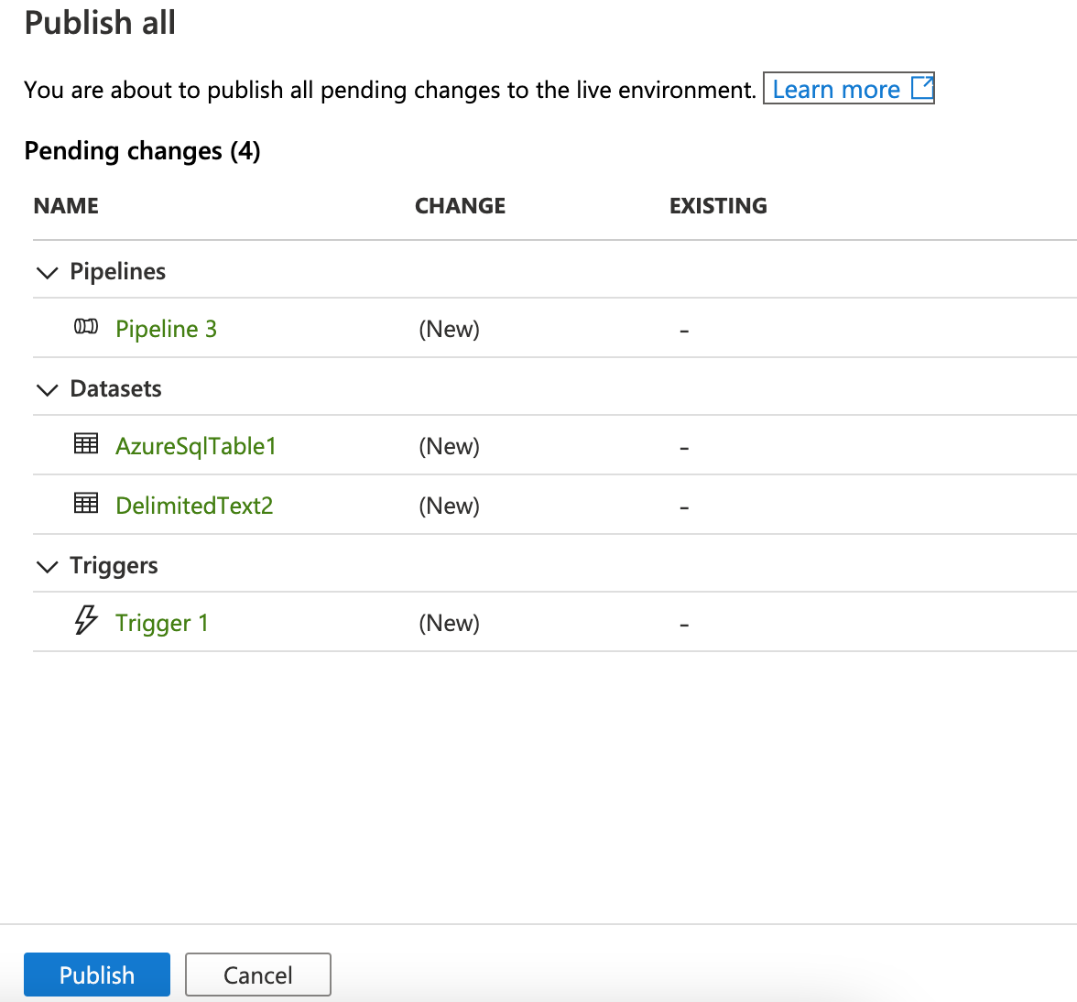

So I edit the trigger to run every 2 minutes and now I am stopping the trigger

1. Storage Event trigger
2. Blob Delete

1. Blob created

Create a pipeline to transfer data from I container to another in adls gen 2

